• News Release •

Date: Feb. 18, 2015
For release: Immediately
For more information, contact: Beth Hawkins, marketing, beth@keokee.com, 208-263-3573 ext. 118; or Billie Jean Gerke, editor, billiej@keokee.com, 208-263-3573, ext 115.

Selkirks Spectacular photographer to present slide show
Special presentation happens Feb. 27 at Yasodhara Ashram

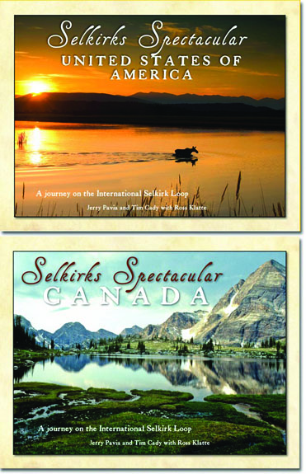
KOOTENAY BAY, B.C., CANADA–Tim Cady spent years photographing all four seasons throughout the region surrounding the International Selkirk Loop for the new book “Selkirks Spectacular,” a journey he will share in a slide show presentation Friday, Feb. 27 at 7:30 p.m. at Yasodhara Ashram, 527 Walker’s Landing Rd., in Kootenay Bay, B.C. The Ashram invites the community to celebrate this spectacular region and its renowned driving tour; the program is free and open to the public, and light refreshments will be served. A book signing will follow the event.
“Selkirks Spectacular,” a photographic journey encircling the spectacular Selkirk Mountains of northern Idaho, eastern Washington and southeastern British Columbia, features amazing images by Cady and fellow U.S. photographer Jerry Pavia, both of Bonners Ferry, Idaho. More than 300 images along with chapters written by Canadian Ross Klatte of Balfour, B.C., on the history, geology, communities, natural features, attractions, and the flora and fauna showcase this beautiful corner of the earth. Pavia and Cady’s photographic odyssey had them exploring every corner of the loop over the course of years in all four glorious seasons.
“We are so excited about this book,” said Stephanie Sims, executive director of the International Selkirk Loop. “Pavia and Cady have a real talent for capturing the beauty of the International Selkirk Loop. The majestic mountains, crystal clear waters, vibrant colors and abundant wildlife come to life on the pages.”
The 180-page, coffee-table book measures 11 inches by 8.5 inches and is full color throughout. The book is unique in that it has two front covers, one for the U.S. side and one for the Canadian side. Halfway through, readers flip the book over and start again from the other side. Published by Keokee Books of Sandpoint, Idaho, “Selkirks Spectacular” (ISBN 978-1-879628-44-1) gives a nod to the multinational nature of the International Selkirk Loop with contributors from both countries.
For more information, contact Yasodhara Ashram at 250-227-9224 or Keokee Books at 208-263-3573, or look up www.KeokeeBooks.com.
–30–

